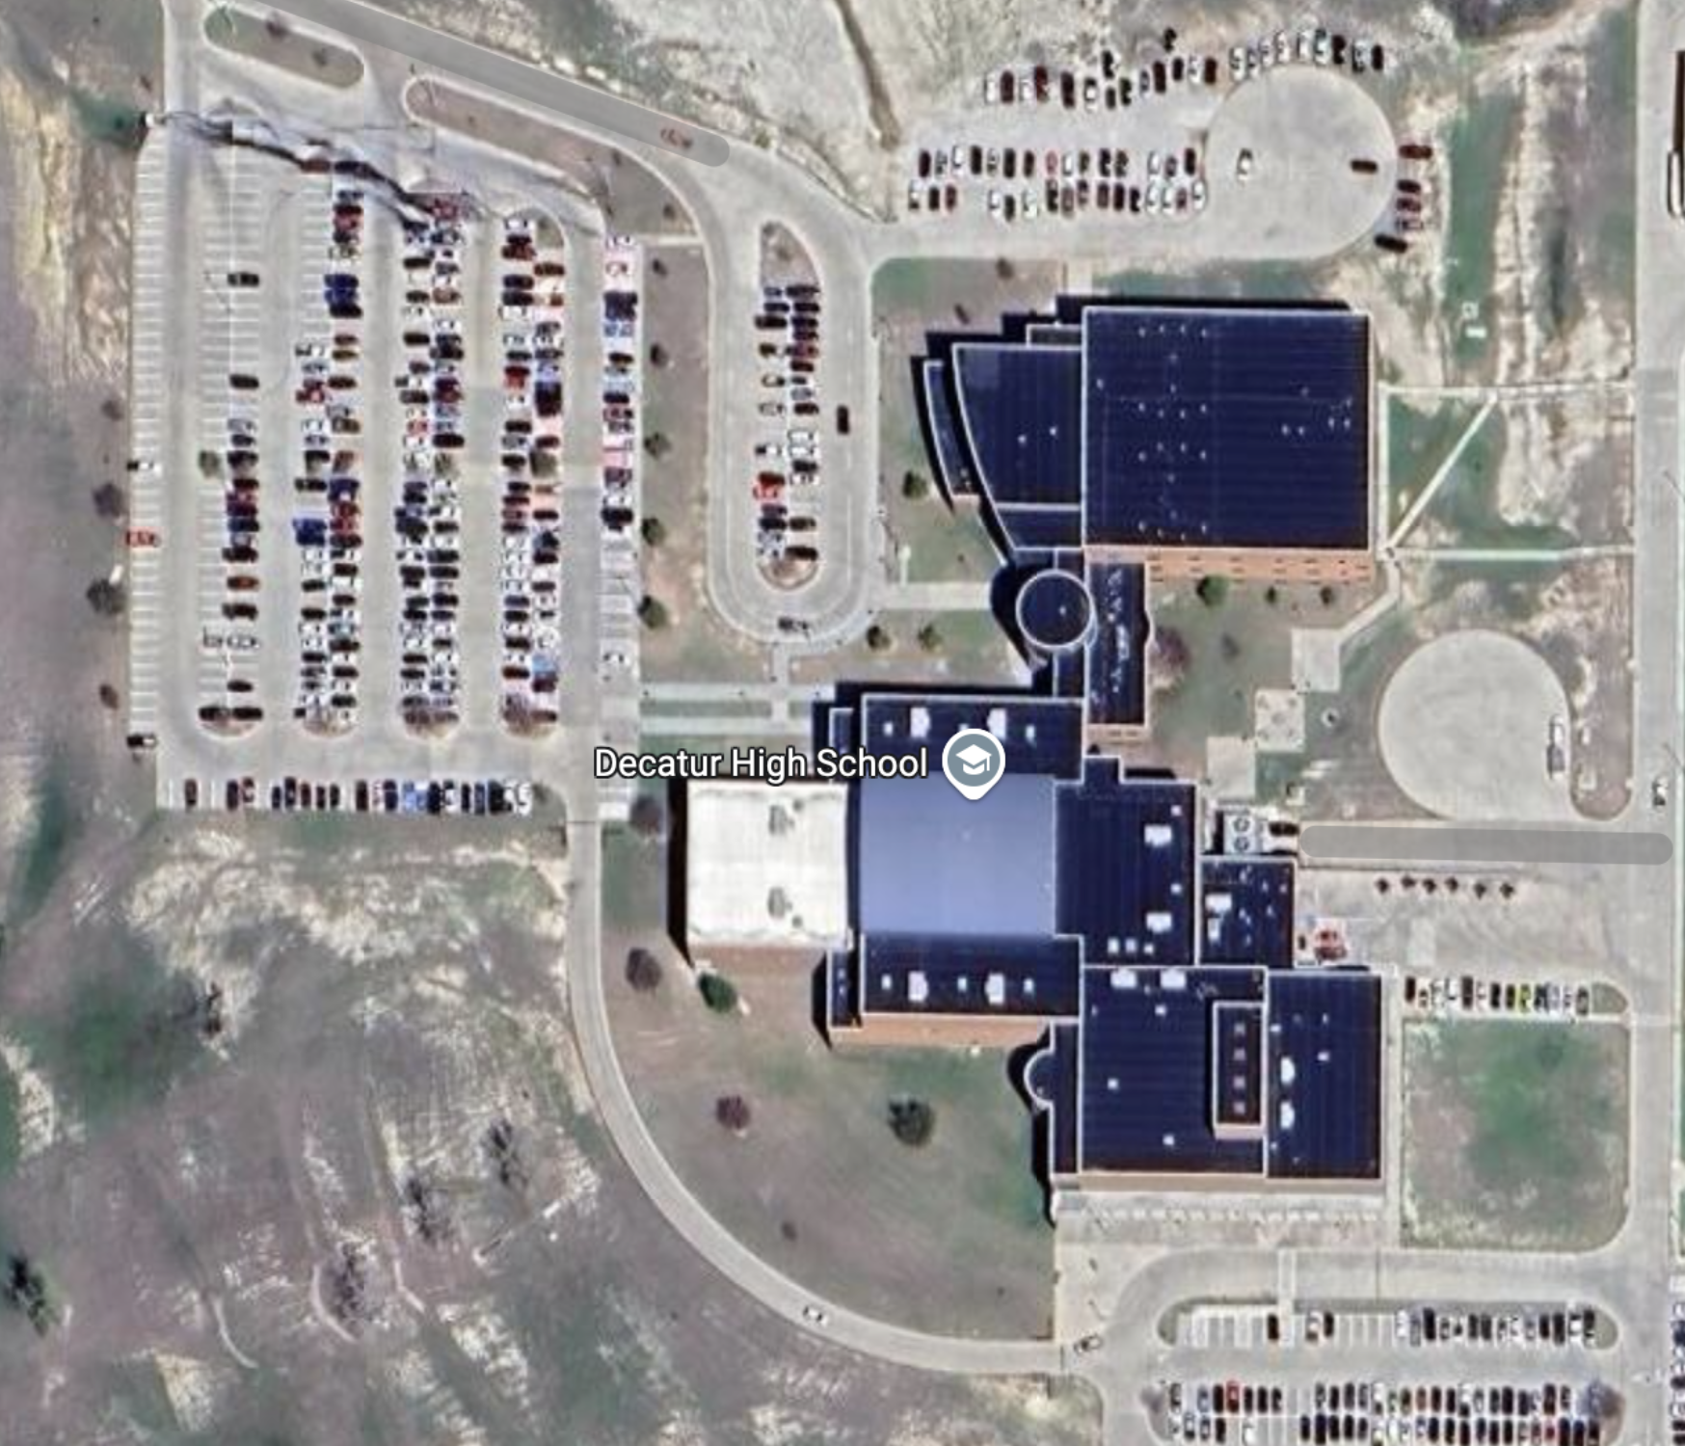

**B**

**U**

**S**

**PARKING**

USE ENTRANCE OFF FM 730

PARKING LOT FOR FANS

USE ENTRANCE OFF OF FM 730

PARK IN DESIGNATED AREAS.

ENTER BUILDING IN THE GYM ENTRANCE

**PLEASE DON’T ENTER BUILDING UNTIL THE APPROPRIATE TIME**

**BAND HALL**

**AUDITORIUM**

**ENTRANCE**

GYM

NO PARKING/ NO ENTRANCE